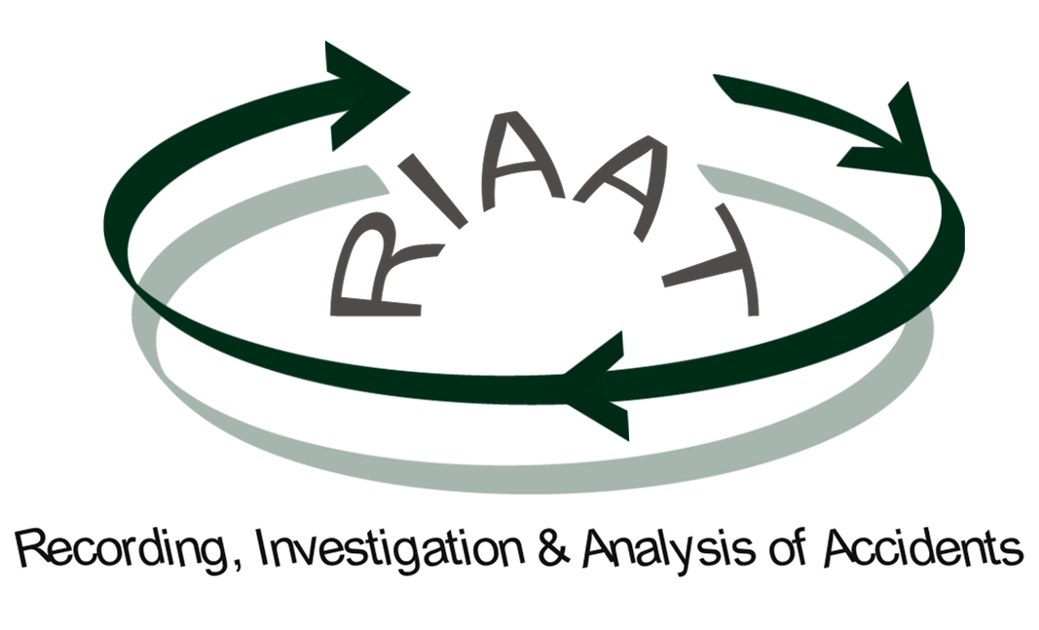

Accident at Work

Dangerous Occurrence

Process No: ___ / Year

Instructions: see Revision 1.1 of user’s manual

May 2010

Case Number: | Record Date: | Organisation Name / Logo | RIAAT Form  Recording, Investigation and Analysis of Accidents
000 | yyyy/mm/dd | Organisation Name / Logo
Accident at Work, If (Yes) Fatal Non Fatal
Dangerous Occurrence
Notified to the Insurance company Yes NO If (Yes), Who notified: xxxxxxxxxxxxxx
PART I: RECORDING

Note: all fields marked with (E) are European harmonised variables (Eurostat, ESAW system).

Section 1 |  | Victim Information
1.1 | Full Name | xxxxxxxxxxxxx
1.2 | Address  Postal code | xxxxxxxxxxxxx | Contact (Phone/Mobile):  xxxxxxxxxxxxx
1.3 | Age ^{(E)} | xx
1.4 | Sex ^{(E)} | Man (1) Woman (2)
1.5 | Nationality ^{(E)}
  xxxxxxxxxxxxx | 0
  (Description and code in accordance with ESAW)
1.6 | Occupation ^{(E)}
  xxxxxxxxxxxxx | 0 | 0
  (Description and code in accordance with ESAW)
1.7 | Department | xxxxxxxxxxxxx
1.8 | Date of Admittance (company) | xxxxxxxxxxxxx  (yyyy/mm/dd)
1.9 | Employment Status ^{(E)}
  xxxxxxxxxxxxx | 0 | 0 |  | 0
  (Description and code in accordance with ESAW)
Section 2 |  | Accident Information
2.1 | Time ^{(E)} /Date of Accident ^{(E)} | The accident occurred at xxxx, on xxxx  (hh:mm - 24 hour clock) (yyyy/mm/dd)
2.2 | Working Environment ^{(E)} | (Identify the workplace or working area where the victim was present at time of the accident - storage, construction site, quarry or mine, office, farming or forest zone, etc.)
  xxxxxxxxxxxxx | 0 | 0 | 0
  (Description and code in accordance with ESAW)
2.3 | Full Accident Description.  How did the accident happen? | (Give the known circumstances of the accident, including what the injured person was doing just before the accident and what happen, i.e., the full sequence of events, and how the person was injured)  xxxxxxxxxxxxxxxxxxxxxxxxxxxxxxxxxxxxxxxxxx  Additional Information (?)  xxxxxxxxxxxxxxxxxxxxxxxxxxxxxxxxxxxxxxxxxx  Attachments: Photo(s) Sketch(s) Other(s) .
2.4 | Active Failures | (In this field, all the “active failures” directly involved in the accident should be identified) - see Section 3 of the user’s manual. Later you will investigate the factors that have contributed to them.  xxxxxxxxxxxxxxxxxxxxxxxxxxxxxxxxxxxxxxxxxx
2.5 | Deviation ^{(E)} and Material Agent ^{(E)} | (Identify the deviation from normal activities or conditions, which led to the accident - the event that corresponds to the last active failure and has caused the accident. The deviation could be, for instance: fire, leak, fall, slipping, wrong body movement, loss of control, etc.) | (The principal Material Agent associated or linked with the deviant event)
  xxxxxxxxxxxxx | 0 | 0
  (Description and code in accordance with ESAW)
  xxxxxxxxxxxxx | 0 | 0 | 0 | 0
  (Name and code in accordance with ESAW)
2.6 | Contact - mode of injury ^{(E)} and Material Agent ^{(E)} | (Describe how the victim was hurt “physical or mental trauma” by the material agent that caused the injury. The mode of injury could be, for instance: the contact with electrical voltage, hazardous substances, crash from fall, struck by object in motion, etc.) | (The principal Material Agent associated or linked with the injuring contact)
  xxxxxxxxxxxxx | 0 | 0
  (Description and code in accordance with ESAW)
  xxxxxxxxxxxxx | 0 | 0 | 0 | 0
  (Name and code in accordance with ESAW)
2.7 | Witness(es) | Yes No If (Yes), number of witnesses: xx | (Fill in the Full name(s) and contact(s) of Witnesses)  Full Name: xxxxxxxxxxxxxxxxxxxxxxxxxx  Contact: xxxxxxxxxxxxxxxxxxxxxxxxxxx  Full Name: xxxxxxxxxxxxxxxxxxxxxxxxxx  Contact: xxxxxxxxxxxxxxxxxxxxxxxxxxx
Section 3 |  | Injury Information
3.1 | Type of injury ^{(E)} | (The physical consequences for the injured person, e.g. bone fracture, wounds etc.)
  xxxxxxxxxxxxx | 0 | 0 | 0
  (Description and code in accordance with ESAW)
3.2 | Body part  injured ^{(E)} | (The part of the body injured, e.g., facial area, hand, back, leg, etc.)
  xxxxxxxxxxxxx | 0 | 0
  (Description and code in accordance with ESAW)
3.3 | Days lost ^{(E)} | Anticipated (calendar days of absence from work)  Without absence 1-3 days 4-6 days 7-13 days 14-20 days  +21 days -1 month 1-3 months 3-6 months 6 months or more  Actual (after return to work): xxx (confirm the total number of days absent; calendar days)
3.4 | Treatment of injury | None First aid only Doctor/Nurse but no hospitalisation Hospitalisation  if the victim was hospitalised indicate the establishment: xxxxxxxxxx
Section 4 Sign Off (Recording)
Signature of employer or representative: (mandatory) | Signature of Injured Person: (if available)
Name in typescript: | Signature of Safety and Health Rep: (if applicable)

PART II: INVESTIGATION & ANALYSIS
Note: Part II deals with the process of investigation and analysis. Do not begin before the interview. Refer to the “User´s Manual” of RIAAT for better elucidation on this part of the process.

Investigation & Analysis Level* : Basic Medium level In depth
* Determine the desired level of investigation & analysis for the accident/incident in question. You should also judge the likelihood of worst consequences. See RIAAT - User´s Manual.
Assessment carried out by (person or team): xxxxxxxxxxx name(s) xxxxxxxxxxx

Section 5 |  | People - Human Failures
5.1 | Classification | What human actions were attributable to this Accident / Incident?  (Explain briefly what happened and classify the failure from the cognitive point of view, e.g.: wrong or inappropriate movements, misjudgement, bad diagnosis, bad planning of an action, etc.): xxxxxxxxxxxxxxxxxxxxxxxxxxxxxxxxxxx  Error Type  Slip or Lapse (1A) Mistake (1B) Violation (2) None, Not applicable (3)  If it was a “violation” (i.e., conscious infringement of rules, although well intended), explain why the person did it: xxxxxxxxxxxx
5.2 | Individual Contributing Factors  (ICF) | Were there any individual factors that may have triggered, or contributed to, the above behaviour / failure?  … add more rows if necessary
  See guidance for description and coding | 0
  See guidance for description and coding | 0
  See guidance for description and coding | 0
5.3 | Prevention | What barriers could have prevented / controlled the above behaviours or faults? (e.g., physical barriers, work procedures, supervision, knowledge and skills, etc.)  … add more rows if necessary
  1 - xxxxxxxxxxxxxxxxxxxxxxxxxxxxxxxx
  2 - xxxxxxxxxxxxxxxxxxxxxxxxxxxxxxxx
  3 - xxxxxxxxxxxxxxxxxxxxxxxxxxxxxxxx
  4 - xxxxxxxxxxxxxxxxxxxxxxxxxxxxxxxx
Section 6 |  | Workplace Factors (WPF)  (These factors are not mutually exclusive and more than one may apply simultaneously)
6.1 | Factors | What were the specific workplace factors that have influenced or have triggered the active failures identified in Part I? (e.g., repetitive work, insufficient illumination, inadequate tools or equipment, complacency with “risk taking” behaviours, slippery floor, lack of qualifications or insufficient training of persons, etc.)  … add more rows if necessary
  See guidance for description and coding | 0
  See guidance for description and coding | 0
  See guidance for description and coding | 0
6.2 | Prevention | What barriers could have prevented / controlled the problems identified above?  … add more rows if necessary
  1 - xxxxxxxxxxxxxxxxxxxxxxxxxxxxxxxx
  2 - xxxxxxxxxxxxxxxxxxxxxxxxxxxxxxxx
  3 - xxxxxxxxxxxxxxxxxxxxxxxxxxxxxxxx
  4 - xxxxxxxxxxxxxxxxxxxxxxxxxxxxxxxx

Section 7 |  | Organisational & Management Factors (OMF)  (These factors are not mutually exclusive and more than one may apply simultaneously)
7.1 | Factors | What organisational and management factors or conditions may have facilitated the previous workplace failures? (e.g., management of contractors, level of supervision, maintenance management, training policy, safety policy, etc.)  … add more rows if necessary
  See guidance for description and coding | 0
  See guidance for description and coding | 0
  See guidance for description and coding | 0
7.2 | Management Improvement and Control | What corrective actions are needed to improve the management of safety?  … add more rows if necessary
  1 - xxxxxxxxxxxxxxxxxxxxxxxxxxxxxxxx
  2 - xxxxxxxxxxxxxxxxxxxxxxxxxxxxxxxx
  3 - xxxxxxxxxxxxxxxxxxxxxxxxxxxxxxxx
  4 - xxxxxxxxxxxxxxxxxxxxxxxxxxxxxxxx
Section 8 | Legal Factors - H&S Legislation
Legal  Issues | (Check if any of the failures identified in sections 6-7 constitutes a legal breach and/ or if the applicable law is, by itself, more of a problem than a solution)  Yes No If (Yes), cite the law or regulation applicable (Column 1) and describe what needs to be done for compliance (Column 2)  … add more rows if necessary
   | 1 - Law / Regulation | 2 - Description
  1 | xxxxxxxxx | xxxxxxxxxxxxxxxxxxxxxxxxxxxxxxxxxxxxxxxxxxxxxxxxxxxx
  2 | xxxxxxxxx | xxxxxxxxxxxxxxxxxxxxxxxxxxxxxxxxxxxxxxxxxxxxxxxxxxxx
  3 | xxxxxxxxx | xxxxxxxxxxxxxxxxxxxxxxxxxxxxxxxxxxxxxxxxxxxxxxxxxxxx
  4 | xxxxxxxxx | xxxxxxxxxxxxxxxxxxxxxxxxxxxxxxxxxxxxxxxxxxxxxxxxxxxx
Section 9 Sign Off (Investigation & Analysis)
Signature of Investigator: | Date (year/month/day):
Signature of Reviewer / or Team Leader: | Date (year/month/day):

PART III: PLAN OF ACTION

Section 10 | Verify your Risk Assessment
Before deciding the actual Plan of Action (Section 11), compare the statements in Part I and all the findings (Part II) with the applicable Risk Assessment (RA) records. Check if the hazards, human actions, etc., and the risks involved in this particular occurrence had actually been considered in the risk assessment(s). If RA exists and all the relevant risks were considered, ask why it failed to prevent this particular case.
xxxxxxxxxxxxxxxxxxxxxxxxxxxxxxxxxxxxxxxxxxx
Establish whether or not the applicable RA is still good enough or needs improvement/ revision; if revision is recommended enter this in Section 11.
Section 11 | Plan of Action  Priority: 1 - Short - term (< 1 month) 2 - Medium - term (1-6 months) 3 - Long - term (> 6 months)
This section must address the specific actions to be taken to prevent or control the problems/ faults identified in Part I and Part II
What? | Who? | Estimate Cost | Priority
xxxxxxxxxxxxxxxxxxxxxxxx | xxxxxx | xxxxx | x
 | .

Section 12 Sign Off (Proposed Plan of Action)
Approved by:  (Signature of Responsible/ or Team Leader) | Date (year/month/day):

Section 13 Sign Off (Follow up/ Completion)
Confirmed/ Verified by:  (Signature of Responsible for follow up) | Date (year/month/day):

PART IV: ORGANISATIONAL LEARNING

Section 14 |  | Lesson(s) Learnt / Discussion  (Safety learning across the whole organisation is the real “added value” and the ultimate goal of the RIAAT process. However, not all occurrences offer the same level of learning opportunity. In this Section the main questions to address are as follows)
14.1 | Lessons Extracted | - Was any relevant lesson learnt from this particular case?  Yes; explain (what lesson? how? who?)  (Try to pinpoint the critical aspects; it may be useful to attach draws or photos of “wrong” and “right” situations to illustrate the objective. The statement registered here, may be the result of a group discussion when the plan of action was decided.)  xxxxxxxxxxxxxxxxxxxxxxxxxxxxxxxxxxxxxxxxxxxxxxxxxxxxxxxxxxxxxxxxxxxxxxxxx  No, Not Really; explain why not  xxxxxxxxxxxxxxxxxxxxxxxxxxxxxxxxxxxxxxxxxxxxxxxxxxxxxxxxxxxxxxxxxxxxxxxxx
14.2 | Use/ Application of Knowledge | - Is this case eligible/ suitable for future training purposes?  Yes No, Not Really If (Yes), in what circumstances or occasions?  xxxxxxxxxxxxxxxxxxxxxxxxxxxxxxxxxxxxxxxxxxxxxxxxxxxxxxxxxxxxxxxxxxxxxxxxx
Section 15 | Dissemination / Diffusion
Diffusion of Information | WHOM - internal? (Decide who are the relevant workers/ managers/ groups/ occupations/ departments, etc., that should be fully aware of this case, including the improvement actions established.)  xxxxxxxxxxxxxxxxxxxxxxxxxxxxxxxxxxxxxxxxxxxxxxxxxxxxxxxxxxxxxxxxxxxxxxxxx  WHOM - external? (External diffusion also recommended? Is this a safety relevant lesson to share with any of your business partners, suppliers, clients, etc.?)  xxxxxxxxxxxxxxxxxxxxxxxxxxxxxxxxxxxxxxxxxxxxxxxxxxxxxxxxxxxxxxxxxxxxxxxxx  HOW? (Propose the appropriate means of dissemination, e.g., letter, newsletter, meeting presentation, leaflet, “point-to-point” protocol, etc. - the physical means of dissemination will depend mostly on the company’s practices and available resources)  xxxxxxxxxxxxxxxxxxxxxxxxxxxxxxxxxxxxxxxxxxxxxxxxxxxxxxxxxxxxxxxxxxxxxxxxx
Section 16 Sign Off (Organisational Learning)
Approved by:  (Signature of Responsible/ or Team Leader) | Date (year/month/day):

GUIDANCE NOTES TO FILL IN THE FORM

PART I | RECORDING (Sections 1 - 4)

Part I is designed to ensure the company’s internal recording of the essential information concerning the accident, which in all the EU countries is a legal duty of the employer (Art. 9 §1c. of Framework Directive 89/391/EEC).
This part is aligned with the Eurostat methodology for the production of European statistics; in Sections 1-3, all fields identified with an “E” are Eurostat harmonised variables and the corresponding codes may be used (c.f. linked document: http://ec.europa.eu/employment_social/news/2002/apr/1130_en.pdf).
Note that this internal record does not replace the (employer’s or self-employed) legal obligation of reporting accidents to the responsible Authority (Art. 9 §1d. of Framework Directive 89/391/EEC) and/or Insurer.

PART II | INVESTIGATION & ANALYSIS (Sections 5 - 9)

Part II directs the analyst to investigate and register the causes of the accident and their underlying factors; it is structured into four layers of concern: the person, the local workplace, the organisational/management factors and finally, the H&S legislation. An accident model is embedded in this investigation protocol and all the relevant details, including a set of classification schemes, are given in the User’s Manual of the RIAAT process.
The first step is to decide the appropriate level of detail, since not all accidents have the same learning potential for improving safety. After interviewing the people involved in the accident, apply the decision tree proposed in the User’s Manual. In RIAAT, there are three options for the investigation level: basic, medium and in-depth, depending on the particular circumstances. You may adjust the decision criteria to your needs. If you decide to go for an “in-depth” investigation, then Sections 5-8 must be completed.
Even at the very basic level, this Part of the process should help you complying with the minimum requirements of the Framework Directive 89/391/EEC (Art.6, §1-2), which prompts the employer to take the necessary actions for the control of risks. This will be the purpose of Part III.

PART III | PLAN OF ACTION (Sections 10 - 13)

Section 10 intends to ensure that you are in possession of a valid assessment of the risks and/or that you revise it in the light of this particular occurrence (Art.6 §3a and Art.9 §1a of Framework Directive 89/391/EEC).
Section 11 prompts you to list and prioritise the plan of action needed to prevent new occurrences.

PART IV | ORGANISATIONAL LEARNING (Sections 14 - 16)

This final stage helps you to make sure that the significant lessons are extracted (Section 14) and also shared (Section 15) with key persons. This feedback information is good practice for the continuous improvement of safety, which in turn, is the main goal of any H&S management system.

